# Github Hosted Maven

1. Install Git and make a GitHub account.
2. Install Eclipse, follow instructions here: <https://www.eclipse.org/downloads/packages/installer>.
3. In Eclipse, create a Maven project. Select File -> New -> Other -> Maven Project

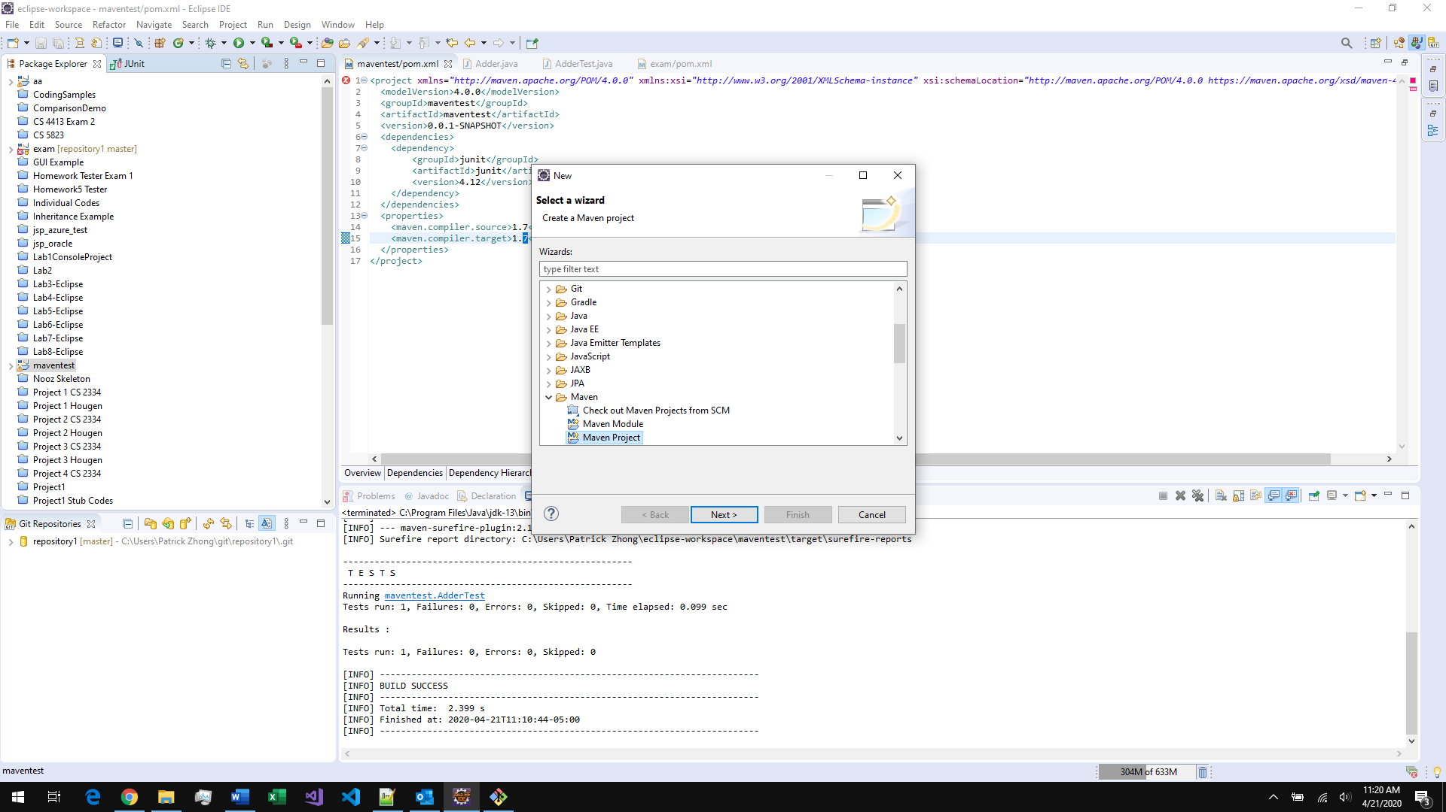

1. Select a workspace location and check ‘Create simple project’, then press next

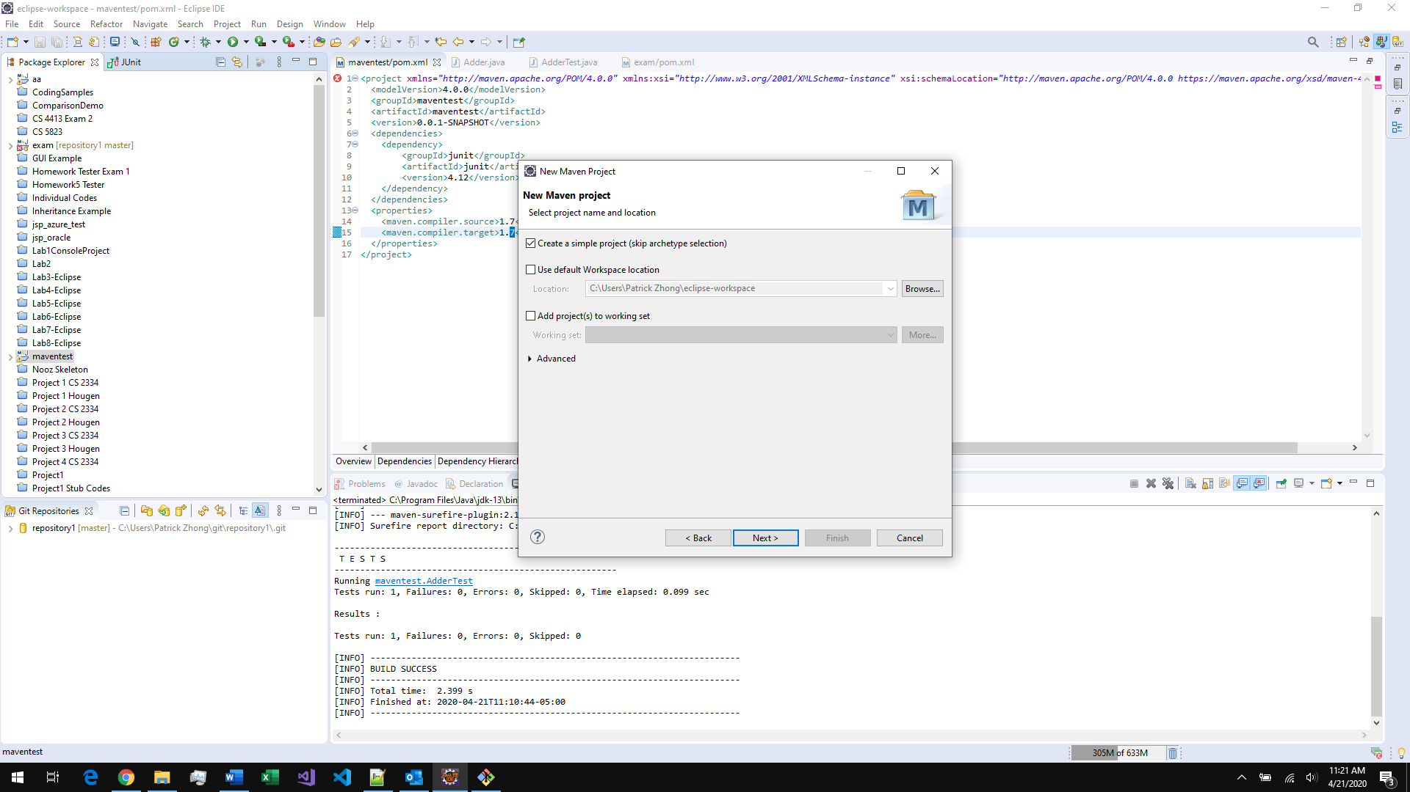

1. Enter a group id and an artifact Id. Then press Finish
2. Open the pom.xml file. Add JUnit 4 as a dependency for your Maven Project in you pom.xml file and set the compiler. To do this insert this after the </version> tag and before the </project> tag:

<dependencies>

<dependency>

<groupId>junit</groupId>

<artifactId>junit</artifactId>

<version>4.12</version>

</dependency>

</dependencies>

<properties>

<maven.compiler.source>1.7</maven.compiler.source>

<maven.compiler.target>1.7</maven.compiler.target>

</properties>

Final result for the pom.xml file should look similar to this, the information above the dependencies tag may be different:

<project xmlns="http://maven.apache.org/POM/4.0.0" xmlns:xsi="http://www.w3.org/2001/XMLSchema-instance" xsi:schemaLocation="http://maven.apache.org/POM/4.0.0 https://maven.apache.org/xsd/maven-4.0.0.xsd">

<modelVersion>4.0.0</modelVersion>

<groupId>maventest</groupId>

<artifactId>maventest</artifactId>

<version>0.0.1-SNAPSHOT</version>

<dependencies>

<dependency>

<groupId>junit</groupId>

<artifactId>junit</artifactId>

<version>4.12</version>

</dependency>

</dependencies>

<properties>

<maven.compiler.source>1.7</maven.compiler.source>

<maven.compiler.target>1.7</maven.compiler.target>

</properties>

</project>

1. Put your Maven Project into Git.
2. Right click your eclipse project and select share then share project.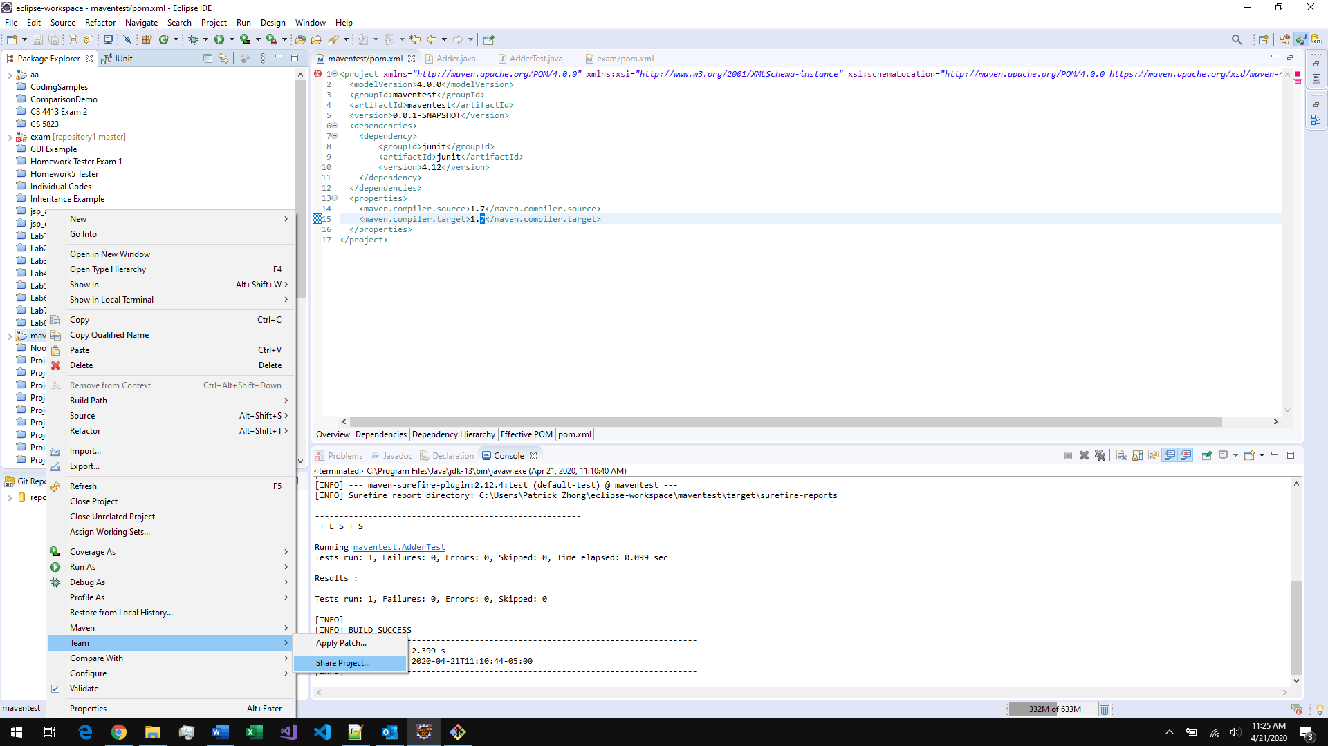
3. Create a new git repository, press create and enter a name:

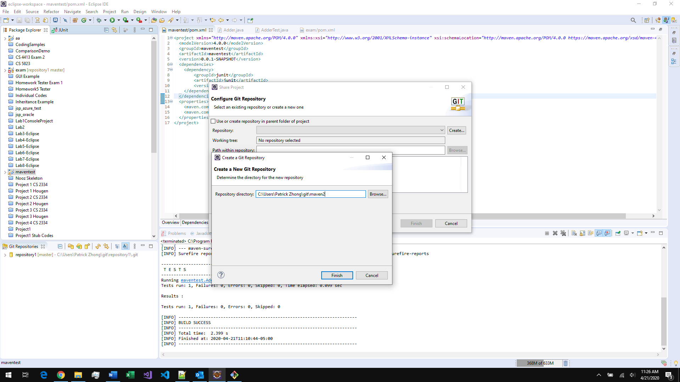

1. Create a new GitHub and add it as a remote.
2. Go to Github and select actions.
3. Go to ‘Setup up a workflow yourself’
4. Create maven.yml and add this content:

# This workflow will build a Java project with Maven

# For more information see: https://help.github.com/actions/language-and-framework-guides/building-and-testing-java-with-maven

name: Java CI with Maven

on:

push:

branches: [ master ]

pull_request:

branches: [ master ]

jobs:

build:

runs-on: ubuntu-latest

steps:

- uses: actions/checkout@v2

- name: Set up JDK 1.8

uses: actions/setup-java@v1

with:

java-version: 1.8

- name: Build with Maven

run: mvn -B package --file "exam/pom.xml"

1. Change “exam/pom.xml” to NAME_OF_YOUR_MAVEN_PROEJCT/pom.xml
2. Press Start commit and it should work.

Reference <https://help.github.com/en/actions/language-and-framework-guides/building-and-testing-java-with-maven>.

# GCP

Running on GCP:

1. Create an Ubuntu 18.04 VM on GCP and install Maven using 'sudo apt install maven'.

2. Follow instructions here to add a GCP VM to your repo: <https://help.github.com/en/actions/hosting-your-own-runners/adding-self-hosted-runners>. Run the application.

3. Copy the .yml file from the section 'Github hosted Maven'. Change the line 'runs-on: ubuntu-latest' to 'runs-on: self-hosted'. This makes your GCP VM run the actions.

4. Your .yml file should similar to .github/workflows/mavenGCP.yml:

# This workflow will build a Java project with Maven

# For more information see: https://help.github.com/actions/language-and-framework-guides/building-and-testing-java-with-maven

name: Java CI with Maven - GCP

on:

push:

branches: [ master ]

pull_request:

branches: [ master ]

jobs:

build:

runs-on: self-hosted

steps:

- uses: actions/checkout@v2

- name: Set up JDK 1.8

uses: actions/setup-java@v1

with:

java-version: 1.8

- name: Build with Maven

run: mvn -B package --file "exam/pom.xml"

OPTIONAL. You can configure the runner application as a service, see second reference below.

Reference:

- <https://help.github.com/en/actions/hosting-your-own-runners/about-self-hosted-runners>

- <https://help.github.com/en/actions/hosting-your-own-runners/configuring-the-self-hosted-runner-application-as-a-service>

# GCP Docker

Docker GCP:

1. Install Docker on your VM. See: https://docs.docker.com/engine/install/ubuntu/

2. Copy the text from the .yml file from the section 'Running on GCP' and start creating a new GitHub Action using Actions ->.set up a workflow yourself -> and enter the text there.

3. Change the line '- name: Build with Maven' to '- name: Docker build'

4. Change the line 'run: mvn -B package --file "exam/pom.xml"' to 'run: docker build -t demo .'

5. Your .yml should now look like .github/workflows/mavenDockerGCP.yml:

# This workflow will build a Java project with Maven

# For more information see: https://help.github.com/actions/language-and-framework-guides/building-and-testing-java-with-maven

name: Java CI with Maven Docker GCP

on:

push:

branches: [ master ]

pull_request:

branches: [ master ]

jobs:

build:

runs-on: self-hosted

steps:

- uses: actions/checkout@v2

- name: Set up JDK 1.8

uses: actions/setup-java@v1

with:

java-version: 1.8

- name: Docker build

run: docker build -t demo .

6. Press start commit.

7. Add a Dockerfile to the project with these contents, changing 'exam' to the name of your maven project:

FROM maven:3.6.0-jdk-11-slim AS build

COPY exam/src /home/app/src

COPY exam/pom.xml /home/app

RUN mvn -f /home/app/pom.xml test

Reference:

- <https://hub.docker.com/_/maven>

- <https://docs.docker.com/engine/reference/builder/>

- <https://help.github.com/en/actions>